Lab 5: PCA as compression — Solutions
  - F71RA Machine Learning for Risk and Insurance 1
Yubo Rasmussen
Table of contents

Before you start
In Lab 4 we used PCA to describe data: which variables move together, and which cars look alike. This lab looks at PCA from a different angle, as a way to compress data. If five features can be squeezed into two numbers per car, how much is lost when we try to get the five back? This question leads directly to autoencoders in Lab 6, which are neural networks trained to do exactly this. They can also compress in nonlinear ways that PCA cannot.
We stay with the sports car data and the five log features from Lab 4, Part 4. Part 1 checks the features before using them. Part 2 builds PCA from the singular value decomposition, step by step, following the code in the lecture slides. Part 3 measures the reconstruction error and works out exactly where it comes from. Part 4 asks whether PCA fitted on some cars works on cars it has never seen. Part 5 connects PCA to autoencoders.
Learning objectives. By the end of this lab you should be able to
- check the distribution of features before PCA with scatter plot matrices, density plots and QQ plots;
- compute principal components with svd(), and check the result against princomp();
- reconstruct data from $p$ principal components and compute the reconstruction error;
- explain the link between the reconstruction error and the discarded eigenvalues;
- fit PCA on a training set and apply it correctly to new data;
- describe PCA as a linear encoder–decoder, and explain why a nonlinear one might do better.
A clean start. Older notebooks begin with rm(list = ls()). This deletes the objects in your workspace, but it does not unload packages or reset options, so it is not a true fresh start. In RStudio, Session → Restart R (Ctrl/Cmd + Shift + F10) is better. When you render a Quarto document, it always runs in a fresh R session anyway, which is one reason to render your work regularly.
Packages. Install anything missing with install.packages().
library(tidyverse)
library(GGally) # ggpairs()
library(ggcorrplot) # ggcorrplot()

Part 1: Look before you compress
Make sure SportsCars.csv is in the same folder as this notebook. We recreate the five features from Lab 4:
$$x_{1}=log\frac{\text{weight}}{\text{max_power}}, x_{2}=log\frac{\text{max_power}}{\text{cubic_capacity}}, x_{3}=log(\text{max_torque}), x_{4}=log(\text{max_engine_speed}), x_{5}=log(\text{cubic_capacity}),$$
and split the cars into three groups by the Ingenbleek–Lemaire index tau: sports cars ($τ<17$), a middle group ($17≤τ<21$), and the rest ($τ≥21$).
SC <- read_delim("SportsCars.csv", delim = ";", show_col_types = FALSE) %>%
mutate(x1 = log(weight / max_power),
x2 = log(max_power / cubic_capacity),
x3 = log(max_torque),
x4 = log(max_engine_speed),
x5 = log(cubic_capacity),
sports_type = cut(tau, breaks = c(0, 17, 21, 100), right = FALSE,
labels = c("tau < 17 (sports car)",
"17 <= tau < 21",
"tau >= 21")))
count(SC, sports_type)
# A tibble: 3 × 2
sports_type n
<fct> <int>
1 tau < 17 (sports car) 72
2 17 <= tau < 21 131
3 tau >= 21 272

Scatter plot matrix
ggpairs() draws every pair of variables against each other: scatter plots below the diagonal, densities on the diagonal and correlations above it.
ggpairs(SC, columns = c("x1", "x2", "x3", "x4", "x5"),
mapping = aes(colour = sports_type, alpha = 0.5),
upper = list(continuous = wrap("cor", size = 3)))
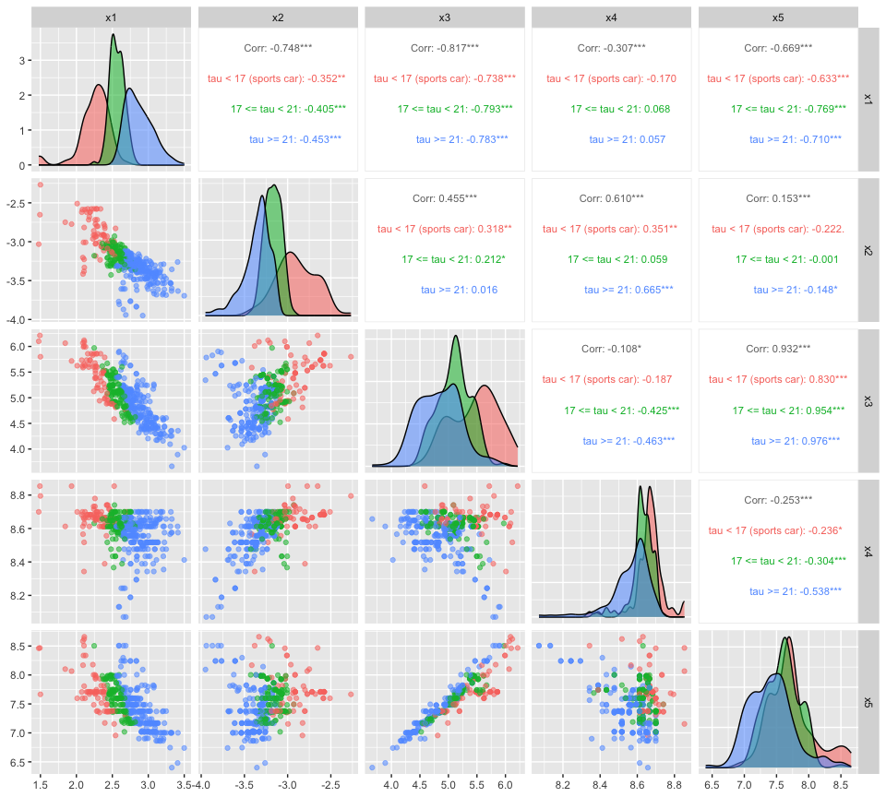
Q1. Which pairs of features are most strongly related? On which feature(s) do the three tau groups separate most clearly? Is any feature on its own enough to identify sports cars?
Answer. $x_{3}$ (torque) and $x_{5}$ (engine size) are almost collinear (correlation 0.93). $x_{1}$ (weight per kW) is strongly negatively correlated with $x_{3}$ (−0.82), $x_{2}$ (−0.75) and $x_{5}$ (−0.67). The groups separate most clearly on $x_{1}$: the sports cars have the lowest weight per kW, the $τ≥21$ group the highest, and the middle group sits in between. This is no surprise, since tau is itself built from similar quantities. But even on $x_{1}$ the group densities overlap, so no single feature is enough. That is why we combine them.

Are the features roughly normal?
PCA does not require normal data, but it is built on variances and correlations. These summarise the data well when the distributions are roughly symmetric without extreme outliers, and badly when they are not. The function below plots each feature’s density together with a normal density that has the same mean and standard deviation.
density_plot <- function(var_name) {
v <- SC[[var_name]]
dens <- density(v)
tibble(x = dens$x, empirical = dens$y,
normal = dnorm(dens$x, mean = mean(v), sd = sd(v))) %>%
ggplot(aes(x = x)) +
geom_line(aes(y = empirical), linewidth = 1) +
geom_line(aes(y = normal), linewidth = 1, colour = "blue", linetype = "dashed") +
labs(x = var_name, y = "density",
title = paste("Density of", var_name, "(dashed: normal fit)"))
}
density_plot("x1")
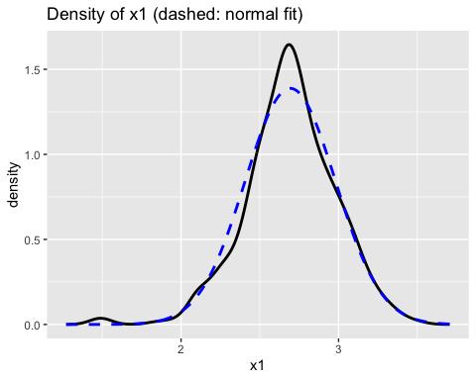
density_plot("x4")
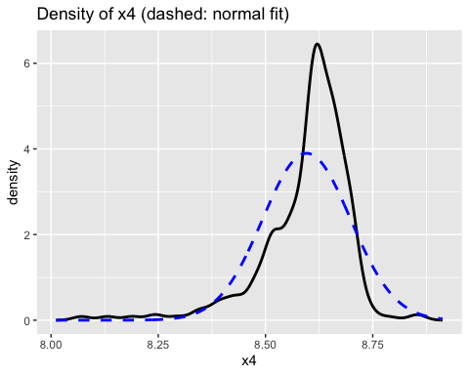
QQ plots show the same comparison in a way that makes the tails easier to see:
par(mfrow = c(1, 5))
for (v in c("x1", "x2", "x3", "x4", "x5")) {
qqnorm(SC[[v]], main = v)
qqline(SC[[v]], col = "red", lty = 2, lwd = 2)
}
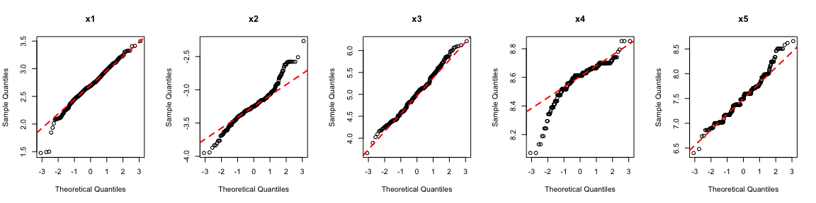
par(mfrow = c(1, 1))
Q2. Which feature looks least normal, and in what way? Could you have guessed this from the raw data? (Hint: summary(SC$max_engine_speed).) Why might this feature cause trouble for PCA later?
summary(SC$max_engine_speed)
Min. 1st Qu. Median Mean 3rd Qu. Max.
3200 5200 5500 5436 5750 7000
Answer. $x_{4}$, the log of maximum engine speed, is clearly the least normal. It has a long left tail (skewness about −1.8): most cars rev to between 5,000 and 6,000 rpm, but a group of large, low-revving engines (down to 3,200 rpm) sits far below. In the QQ plot the lower-left points bend well below the line. The other features are reasonably close to normal, apart from slightly heavy tails in $x_{1}$ and $x_{2}$. Cars that are unusual on $x_{4}$ will not fit the main linear pattern in the data, so we should expect them to be poorly described by a few principal components. We will meet them again in Part 3.

Part 2: PCA via the SVD

Standardise
Build the $n×5$ design matrix of features and standardise each column to mean 0 and standard deviation 1.
X_raw <- SC %>% select(x1:x5) %>% as.matrix()
X <- scale(X_raw)
n <- nrow(X)
round(colMeans(X), 10)
x1 x2 x3 x4 x5
0 0 0 0 0
apply(X, 2, sd)
x1 x2 x3 x4 x5
1 1 1 1 1
ggcorrplot(cor(X), lab = TRUE)
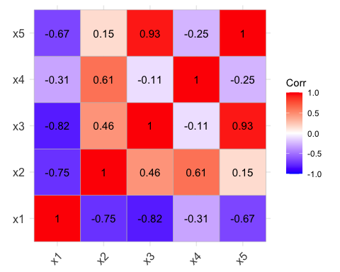

The singular value decomposition
Any $n×q$ matrix can be written as $X=UDV^{⊤}$. Here $U$ ($n×q$) and $V$ ($q×q$) have orthonormal columns, and $D$ is diagonal with singular values $d_{1}≥…≥d_{q}≥0$. As in Lab 4, Part 3, the columns of $V$ are the principal component loadings, the scores are $Y=XV=UD$, and the component variances are $d_{j}^{2}/(n−1)$.
svdX <- svd(X)
str(svdX)
List of 3
$ d: num [1:5] 37.49 28.04 11.46 6.47 2.12
$ u: num [1:475, 1:5] -0.0781 -0.1116 -0.1211 -0.1044 -0.0724 ...
$ v: num [1:5, 1:5] -0.558 0.412 0.539 0.126 0.461 ...
V <- svdX$v
Q3. Check that $V$ is orthogonal, i.e. $V^{⊤}V=I$. The off-diagonal entries will not be exactly zero. Why not, and how should you test for “equal to the identity” in code?
t(V) %*% V
[,1] [,2] [,3] [,4] [,5]
[1,] 1.000000e+00 1.170297e-16 9.724570e-17 -2.461895e-16 5.537811e-17
[2,] 1.170297e-16 1.000000e+00 -1.284815e-16 -2.727955e-17 1.556876e-17
[3,] 9.724570e-17 -1.284815e-16 1.000000e+00 -2.814641e-16 1.781207e-16
[4,] -2.461895e-16 -2.727955e-17 -2.814641e-16 1.000000e+00 7.959705e-17
[5,] 5.537811e-17 1.556876e-17 1.781207e-16 7.959705e-17 1.000000e+00
all.equal(t(V) %*% V, diag(5))
[1] TRUE
Answer. The diagonal entries are 1 and the off-diagonal entries are of order ${10}^{−16}$. Computers store numbers in floating point with about 16 significant digits, so almost every calculation carries a tiny rounding error. Testing t(V) %*% V == diag(5) would return FALSE for most entries. The right tool is all.equal(), which compares numbers up to a small tolerance (about $1.5×{10}^{−8}$ by default), or isTRUE(all.equal(...)) inside an if statement.

Scores and the summary table
Y <- X %*% V
colnames(Y) <- paste0("PC", 1:5)
pca_summary <- tibble(
component = 1:5,
sing_value = svdX$d,
sd_pc = svdX$d / sqrt(n - 1),
prop_var = svdX$d^2 / sum(svdX$d^2),
cum_var = cumsum(prop_var)
)
pca_summary
# A tibble: 5 × 5
component sing_value sd_pc prop_var cum_var
<int> <dbl> <dbl> <dbl> <dbl>
1 1 37.5 1.72 0.593 0.593
2 2 28.0 1.29 0.332 0.925
3 3 11.5 0.527 0.0554 0.980
4 4 6.47 0.297 0.0177 0.998
5 5 2.12 0.0974 0.00190 1
Q4. Compare pca_summary with summary(princomp(X, cor = TRUE)), and the first column of V with the first column of the princomp() loadings. Then look at princomp(X, cor = TRUE)$scale. We already standardised X, so why isn’t it exactly 1?
pca <- princomp(X, cor = TRUE)
summary(pca)
Importance of components:
Comp.1 Comp.2 Comp.3 Comp.4 Comp.5
Standard deviation 1.7221233 1.2881142 0.52653074 0.2971918 0.097444561
Proportion of Variance 0.5931417 0.3318477 0.05544692 0.0176646 0.001899088
Cumulative Proportion 0.5931417 0.9249894 0.98043632 0.9981009 1.000000000
cbind(svd = V[, 1], princomp = pca$loadings[, 1])
svd princomp
x1 -0.5577027 0.5577027
x2 0.4122188 -0.4122188
x3 0.5389689 -0.5389689
x4 0.1262176 -0.1262176
x5 0.4611129 -0.4611129
pca$scale
x1 x2 x3 x4 x5
0.9989468 0.9989468 0.9989468 0.9989468 0.9989468
sqrt((n - 1) / n)
[1] 0.9989468
Answer. The standard deviations and proportions of variance agree exactly. The first components explain 59.3%, 33.2%, 5.5%, 1.8% and 0.2% of the variance, so two components capture 92.5%. The first loading vectors agree up to sign: svd() and princomp() may choose opposite signs (they did when this lab was written), which is fine, as we saw in Lab 4, Q9. scale is 0.99895 rather than 1 because scale() standardised X with the divisor $n−1$, while princomp() measures standard deviations with divisor $n$. A column with sample standard deviation 1 has divisor-$n$ standard deviation $\sqrt{(n−1)/n}=\sqrt{474/475}=0.99895$.
Q5. Plot the scores with ggpairs(), and compute their correlation matrix. What do you notice, and why does it happen?
ggpairs(as_tibble(Y), upper = list(continuous = wrap("cor", size = 3)))
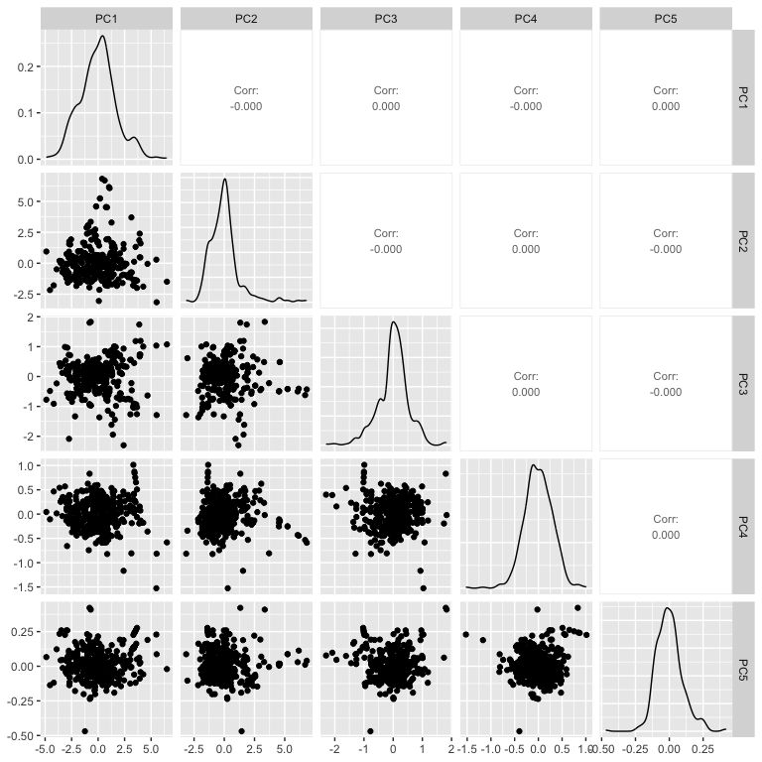
round(cor(Y), 10)
PC1 PC2 PC3 PC4 PC5
PC1 1 0 0 0 0
PC2 0 1 0 0 0
PC3 0 0 1 0 0
PC4 0 0 0 1 0
PC5 0 0 0 0 1
Answer. The scores are uncorrelated: every off-diagonal correlation is zero, up to rounding. The plots also show that their spread shrinks rapidly from PC1 to PC5. Neither is a coincidence. $Y^{⊤}Y=V^{⊤}X^{⊤}XV=D^{2}$, which is diagonal. PCA is a rotation chosen so that the new variables are uncorrelated and ordered by variance. Uncorrelated is not the same as independent, though. Zero correlation only rules out a linear relationship between the scores. Their distributions can still be skewed, and points can still cluster or sit far from the rest, as some do in the PC3 panels.

The first two components
SC <- bind_cols(SC, as_tibble(Y))
ggplot(SC, aes(x = PC1, y = PC2, colour = sports_type)) +
geom_point(alpha = 0.7) +
labs(x = "First principal component", y = "Second principal component",
colour = NULL, title = "Sports cars on the first two principal components")
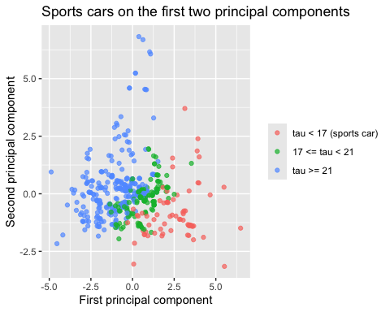
The base R biplot() function adds the loadings as arrows. It needs the scores and loadings as separate arguments:
biplot(Y[, 1:2], V[, 1:2], expand = 2, cex = c(0.4, 1.2),
xlab = "PC1", ylab = "PC2", xlim = c(-7, 7), ylim = c(-7, 7))
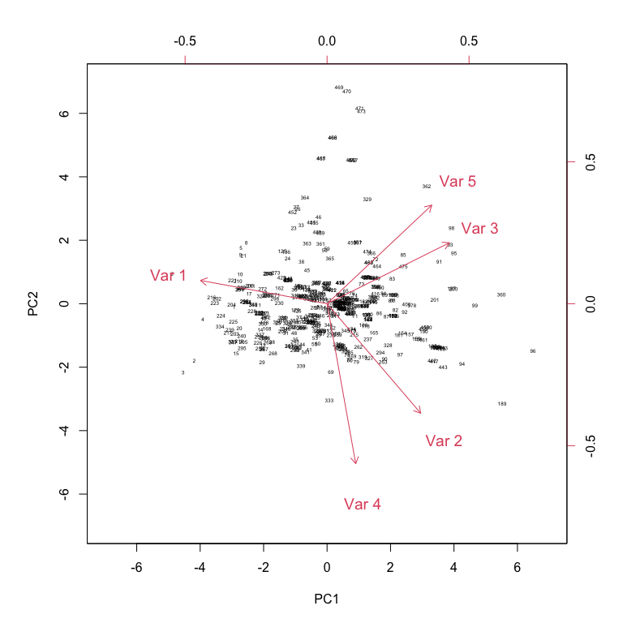

Part 3: Reconstruction error

Compress, then decompress
If we keep only the first $p$ components, each car is described by $p$ numbers, its scores $Y_{p}=XV_{p}$, where $V_{p}$ is the first $p$ columns of $V$. To get back to the five features we map the scores back with $V_{p}^{⊤}$:
$${\hat{X}}_{p}=Y_{p}V_{p}^{⊤}=XV_{p}V_{p}^{⊤}.$$
${\hat{X}}_{p}$ is the projection of each car onto the best-fitting $p$-dimensional plane through the data. The reconstruction error is the root mean squared distance between each car and its projection,
$$\text{RE}(p)=\sqrt{\frac{1}{n}\sum_{i=1}^{n}{{\left\|x_{i}−{\hat{x}}_{i,p}\right\|}^{2}}}.$$
Q6. Compute $\text{RE}(p)$ for $p=1,…,5$. What is it for $p=5$, and why? Plot $\text{RE}(p)$ against $p$.
recon_error <- function(X, V, p) {
Vp <- V[, 1:p, drop = FALSE]
X_hat <- X %*% Vp %*% t(Vp)
sqrt(sum((X - X_hat)^2) / nrow(X))
}
RE <- sapply(1:5, function(p) recon_error(X, V, p))
round(RE, 5)
[1] 1.42478 0.61177 0.31243 0.09734 0.00000
tibble(p = 1:5, RE = RE) %>%
ggplot(aes(x = p, y = RE)) +
geom_line() + geom_point() +
labs(x = "Number of components p", y = "Reconstruction error")
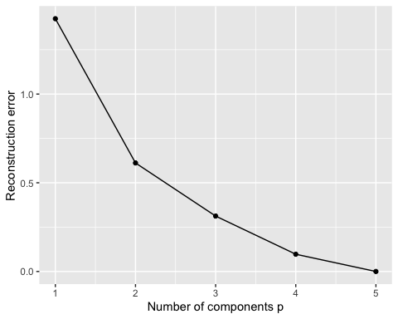
Answer. The reconstruction errors are 1.425, 0.612, 0.312, 0.097 and 0. With $p=5$ nothing is thrown away: $V$ is square and orthogonal, so $VV^{⊤}=I$ and ${\hat{X}}_{5}=X$. The error falls quickly up to $p=2$ and slowly afterwards, which matches the scree plot from Lab 4. For comparison, the “reconstruction” with $p=0$ (predicting every car as the average car) has error $\sqrt{5(n−1)/n}≈2.23$.
drop = FALSE matters in recon_error(). Without it, V[, 1:1] would be a plain vector rather than a $5×1$ matrix, and %*% would treat it differently.

Where the error comes from
Q7. Show numerically that
$$\text{RE}(p)^{2}=\frac{n−1}{n}\sum_{j=p+1}^{5}{λ_{j}},$$
where $λ_{j}=d_{j}^{2}/(n−1)$ are the eigenvalues. In words: the squared reconstruction error is the variance we discarded. Can you explain why? (Hint: X−Xp=j>p​ujdjvj⊤.)
lambda <- svdX$d^2 / (n - 1)
discarded <- sapply(1:5, function(p) sum(lambda[-(1:p)]))
round(cbind(RE_squared = RE^2, formula = (n - 1) / n * discarded), 6)
RE_squared formula
[1,] 2.030009 2.030009
[2,] 0.374263 0.374263
[3,] 0.097612 0.097612
[4,] 0.009475 0.009475
[5,] 0.000000 0.000000
Answer. The two columns agree. Using the SVD, $X=\sum_{j=1}^{5}{d_{j}}u_{j}v_{j}^{⊤}$. Projecting onto the first $p$ loadings keeps the first $p$ terms, so the error matrix is j>p​djujvj⊤. The terms are orthogonal to each other, and $u_{j}$, $v_{j}$ have length 1, so the sum of squared entries is j>p​dj2. Dividing by $n$ gives 1nj>p​dj2=n−1nj>p​λj. So “maximise the variance kept” (Lab 4’s view of PCA) and “minimise the reconstruction error” (this lab’s view) are the same problem.

Is PCA really the best?
The Eckart–Young theorem says that no other $p$-dimensional linear projection has a smaller reconstruction error than PCA. We can test this.
Q8. Generate 1,000 random two-dimensional projections. For each, take a random $5×2$ matrix, orthonormalise its columns with qr.Q(qr(...)), and compute the reconstruction error. How does the best random projection compare with PCA’s 0.612?
set.seed(2026)
RE_random <- replicate(1000, {
Q <- qr.Q(qr(matrix(rnorm(10), nrow = 5)))
recon_error(X, Q, 2)
})
summary(RE_random)
Min. 1st Qu. Median Mean 3rd Qu. Max.
0.838 1.573 1.743 1.724 1.880 2.181
min(RE_random) >= RE[2]
[1] TRUE
ggplot(tibble(RE = RE_random), aes(x = RE)) +
geom_histogram(bins = 40) +
geom_vline(xintercept = RE[2], colour = "red", linetype = "dashed") +
labs(x = "Reconstruction error, random 2-d projection", y = "Count")
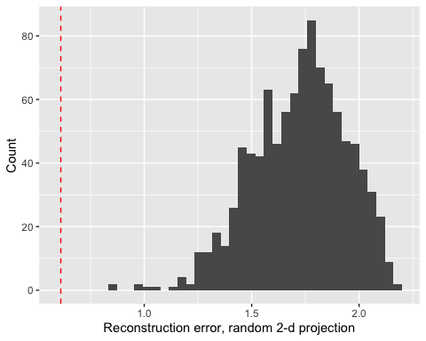
Answer. Every random projection has a larger error than PCA. Even the best of 1,000 is noticeably worse (roughly 0.8, depending on the seed), and the typical random projection has an error of about 1.7, close to the error of the “average car” ($p=0$, 2.23). Finding a good two-dimensional plane in five dimensions by chance is hard. PCA finds the best one directly. This is the Eckart–Young theorem at work. It only covers linear projections, which is the loophole autoencoders exploit (Part 5).

Which cars reconstruct worst?
Q9. Compute each car’s squared reconstruction error with $p=2$ and list the five worst cars with their features. What do they have in common? Link your answer to Q2.
Vp <- V[, 1:2]
X_hat <- X %*% Vp %*% t(Vp)
SC %>%
mutate(err2 = rowSums((X - X_hat)^2),
rpm = max_engine_speed) %>%
arrange(desc(err2)) %>%
select(brand, type, err2, rpm, cubic_capacity, max_power, weight, tau) %>%
head(5)
# A tibble: 5 × 8
brand type err2 rpm cubic_capacity max_power weight tau
<chr> <chr> <dbl> <dbl> <dbl> <dbl> <dbl> <dbl>
1 Ford Thunderbird 5.45 4400 2301 140 1533 15.7
2 Wartburg Berline 4.51 4250 992 37 920 31.2
3 Toyota Cressida 4.12 5600 2466 63 1370 34.3
4 Ford Probe 3.81 4300 2184 108 1340 17.6
5 Ford Mustang 3.52 4800 3273 63 1171 29.2
Answer. The worst-reconstructed cars are large-engined cars with very low maximum engine speeds (around 4,200–4,800 rpm). Three of them are American: a Ford Thunderbird, a Ford Probe and a Ford Mustang. The others are a Toyota Cressida estate and an East German Wartburg. These are the cars in the long left tail of $x_{4}$ that we noticed in Q2. They combine features in a way that the dominant linear pattern of the data does not capture, so they sit far from the PC1–PC2 plane. Most of their error lies along PC3, which is largely engine speed against power per litre. For an insurer this is useful: cars with a large reconstruction error are atypical, and a two-number summary is less reliable for exactly those cars.

Part 4: PCA on new data
In practice a PCA is fitted once, say when a pricing model is built, and then applied to new cars as they come onto the market. A fair test of the compression is therefore how well it works on cars that were not used to fit it.
Q10. Split the cars at random into a training set of 380 (80%) and a test set of 95. Using the training set only, compute the column means and standard deviations, standardise, and compute the loadings. Then standardise the test set with the training means and standard deviations and compute the reconstruction errors for $p=1,2,3$ on both sets. Is there evidence of overfitting?
set.seed(2026)
train_idx <- sample(n, size = 380)
X_train_raw <- X_raw[train_idx, ]
X_test_raw <- X_raw[-train_idx, ]
mu <- colMeans(X_train_raw)
sig <- apply(X_train_raw, 2, sd)
X_train <- scale(X_train_raw, center = mu, scale = sig)
X_test <- scale(X_test_raw, center = mu, scale = sig)
V_train <- svd(X_train)$v
tibble(p = 1:3,
train = sapply(1:3, function(p) recon_error(X_train, V_train, p)),
test = sapply(1:3, function(p) recon_error(X_test, V_train, p)))
# A tibble: 3 × 3
p train test
<int> <dbl> <dbl>
1 1 1.43 1.34
2 2 0.612 0.592
3 3 0.310 0.324
Answer. Training and test errors are similar for every $p$. Depending on the split, the test error may even come out slightly lower, because 95 cars is a small sample and the error varies from split to split. (Try a few different seeds.) There is no real sign of overfitting. That is because PCA with $p=2$ estimates only a handful of quantities (five means, five standard deviations and a $5×2$ loading matrix) from 380 cars. A flexible autoencoder with thousands of weights can overfit, and then this comparison becomes essential.
Q11. A colleague standardises the test set using its own means and standard deviations, scale(X_test_raw). Why is this wrong? Think about what happens when you need to score a single new car.
Answer. The transformation is part of the fitted model. The means and standard deviations are estimated parameters, just like the loadings, so they must come from the training data and be applied unchanged to new data. If the test set is standardised with its own statistics, a car’s score depends on which other cars happen to be in the test set. A single new car can’t be standardised by itself at all: its standard deviation is undefined. This is a simple case of data leakage, the same issue as with the train/test split in Lab 3.

Part 5: From PCA to autoencoders
We can describe PCA with $p$ components as two functions:
- an encoder $f(x)=V_{p}^{⊤}x$, which compresses five features into $p$ numbers;
- a decoder $g(y)=V_{p} y$, which expands $p$ numbers back into five features.
PCA chooses $V_{p}$ to minimise the reconstruction error i​xi−g(f(xi))2. An autoencoder is a neural network with the same structure: an encoder network squeezes the input through a narrow middle layer, the bottleneck, and a decoder network expands it again. The weights are trained to minimise the same loss. If both networks are linear with no activation functions, the best autoencoder spans the same subspace as PCA. Adding nonlinear activation functions lets it fit curved surfaces through the data instead of flat planes.
Q12. Write the encoder and decoder as R functions, check that decoder(encoder(x)) reproduces X_hat from Q9 for the first car, and compute the encoding of the first car in the data set.
encoder <- function(x, p = 2) as.vector(t(V[, 1:p]) %*% x)
decoder <- function(y) as.vector(V[, seq_along(y)] %*% y)
x_first <- X[1, ]
encoder(x_first)
[1] -2.927847 -0.109261
all.equal(decoder(encoder(x_first)), unname(X_hat[1, ]))
[1] TRUE
Answer. encoder(X[1, ]) returns the car’s first two principal component scores, i.e. the first two entries of Y[1, ]. Decoding them gives exactly the first row of X_hat. Every car is now represented by two numbers, and the decoder turns those two numbers back into an approximation of all five features.
Q13. Using your answers to Q5 and Q9, explain why a nonlinear autoencoder with a two-dimensional bottleneck might achieve a lower reconstruction error than 0.612. Can it ever do worse than PCA, on the training data?
Answer. PCA can only project onto a flat plane. Q5 showed that the scores are uncorrelated, but that only rules out linear structure. The cars in Q9 sit far from the plane because they follow a different pattern from the bulk of the data (big engines that rev unusually low), and a single flat plane cannot fit both patterns well. A nonlinear encoder and decoder can fit a curved two-dimensional surface, which can bend towards such groups of cars while still fitting the rest. In principle the best nonlinear autoencoder is never worse than PCA on the training data: a network that can represent linear maps includes PCA as a special case. In practice, training a neural network is a non-convex optimisation, so a badly trained network can be worse. On test data a flexible autoencoder can also overfit, which PCA barely does (Q10). Rentzmann and Wüthrich (2019) compare the two on this data set, and you will build an autoencoder yourself in Lab 6.

Stretch: errors in the original units
Reconstruction errors on the standardised log scale are hard to interpret. An underwriter wants to know: if we store only two numbers per car, how far off are the weight, power and engine size we recover?
Undo the standardisation and the log transforms for $p=2$ and $p=3$. Then compute the median absolute percentage error in cubic_capacity, max_power and weight. (Hint: $\hat{\text{cc}}=e^{{\hat{x}}_{5}}$, $\hat{\text{power}}=e^{{\hat{x}}_{2}} \hat{\text{cc}}$, $\hat{\text{weight}}=e^{{\hat{x}}_{1}} \hat{\text{power}}$.)
back_transform <- function(p) {
Vp <- V[, 1:p, drop = FALSE]
Xh <- X %*% Vp %*% t(Vp)
colnames(Xh) <- colnames(X)
Xh <- sweep(Xh, 2, attr(X, "scaled:scale"), "*")
Xh <- sweep(Xh, 2, attr(X, "scaled:center"), "+")
cc <- exp(Xh[, "x5"])
power <- exp(Xh[, "x2"]) * cc
weight <- exp(Xh[, "x1"]) * power
tibble(p = p,
cubic_capacity = median(abs(cc / SC$cubic_capacity - 1)),
max_power = median(abs(power / SC$max_power - 1)),
weight = median(abs(weight / SC$weight - 1)))
}
bind_rows(back_transform(2), back_transform(3)) %>%
mutate(across(-p, ~ scales::percent(.x, accuracy = 0.1)))
# A tibble: 2 × 4
p cubic_capacity max_power weight
<dbl> <chr> <chr> <chr>
1 2 4.6% 3.4% 7.6%
2 3 1.8% 3.3% 7.5%
Answer. With two components the median errors are about 5% for engine size, 3% for power and 8% for weight. Adding a third component brings the engine-size error down to about 2% but hardly changes power or weight. Weight is never one of the five features directly, only through the ratio $x_{1}$, so it is the hardest quantity to recover. Whether 8% is “good enough” depends on the use: it is fine for a rating factor that groups similar cars, but not for recording a car’s specification.

